**SELF QUARATINE**

**(Remembering Ancestors not to call ☹)**

**#COVID 19**

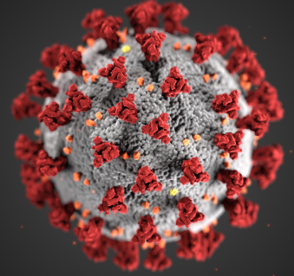

**BAU Runs with help of Antivirus, WFH Enablement, BYOD, Theory Y (McGregor), Team Members + Management**